**Airline Data Management and Analysis Using Power BI**

**Paras Chaturvedi**

**14-08-2025**

**1. Problem Statement**

The airline industry has many moving parts — flight schedules, passenger details, and ticket bookings. Managing all this data efficiently is important to improve operations and customer satisfaction.  
This project uses Power BI to connect, clean, and analyze airline data to provide useful insights for better decision-making.

## ****2. Datasets Used****

1. <Flight_Information.xlsx> – FlightID, FlightNumber, Airline, Destination, Status.
2. <Passenger_Information.xlsx> – PassengerID, FlightID, SeatNumber.
3. <Ticket_Information.xlsx> – TicketID, FlightID, BookingStatus.

## ****3. Task-wise Execution****

### ****Task 1 – Data Preparation and Cleaning****

I loaded all three Excel files into Power BI and cleaned them in Power Query by:

* Removing duplicates and empty rows.
* Fixing data types (ensuring FlightID matched across all tables).
* Trimming and cleaning text columns.**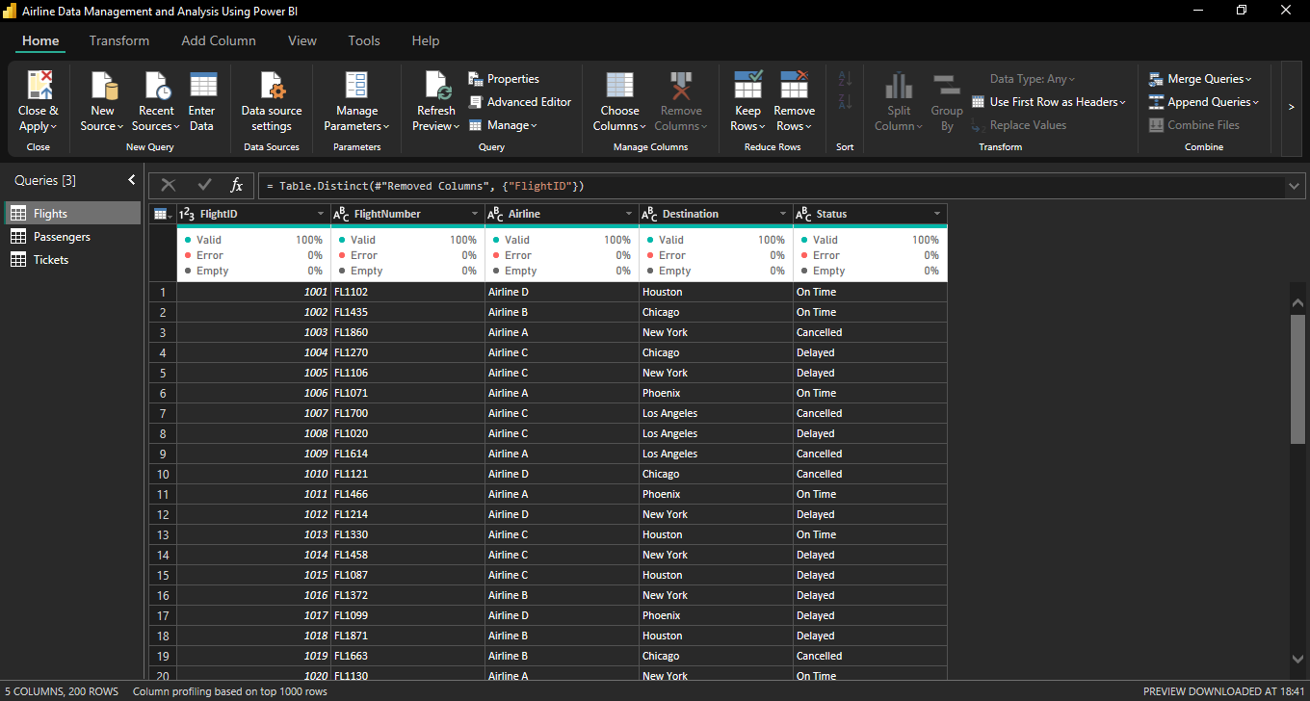**

### ****Task 2 – Data Modeling****

I linked the datasets using **FlightID** as the primary key:

* Flights → Passengers (One-to-Many)
* Flights → Tickets (One-to-Many) 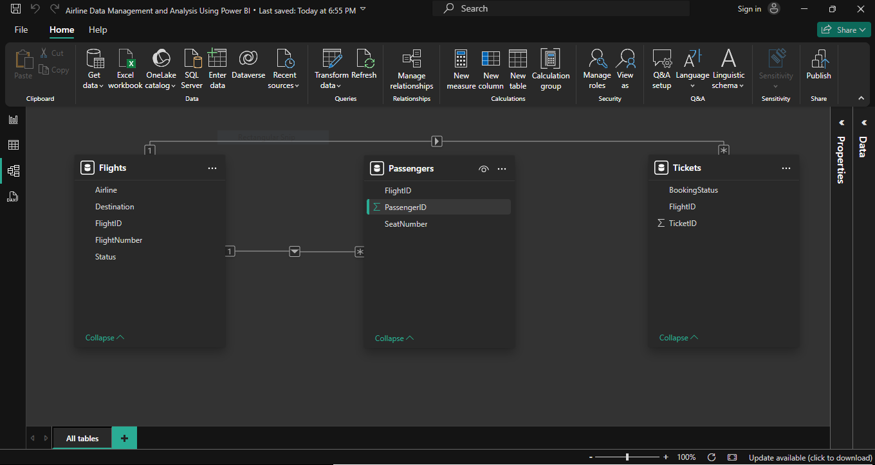

### ****Task 3 – Enhanced Data Insights****

1. **Status Category**: Created a conditional column:
   * If Status = “On Time” or “Arrived” → “Best”
   * Else → “To Be Improved”
2. **Flight Number Only**: Extracted just the number from FlightNumber using Column from Examples. 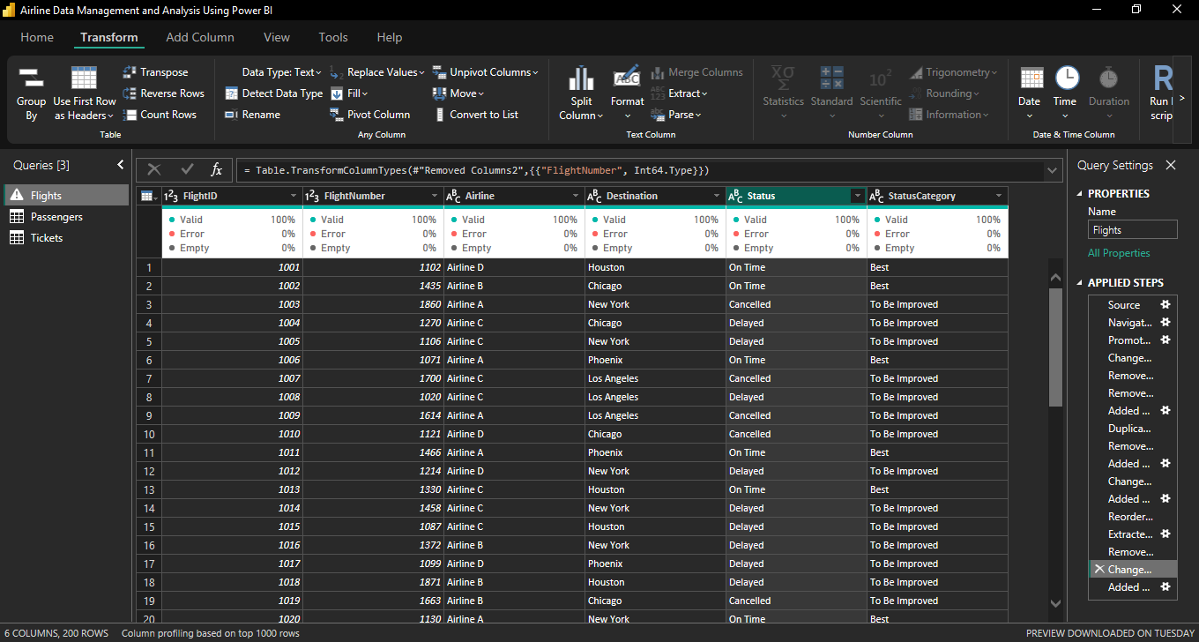

### ****Task 4 – DAX Calculations****

I created measures to calculate:

* **Total Passengers** → DISTINCTCOUNT(Passengers[PassengerID])
* **Total Tickets** → COUNTROWS(Tickets)
* **Best Flights Table** → FILTER(Flights, Flights[StatusCategory] = "Best")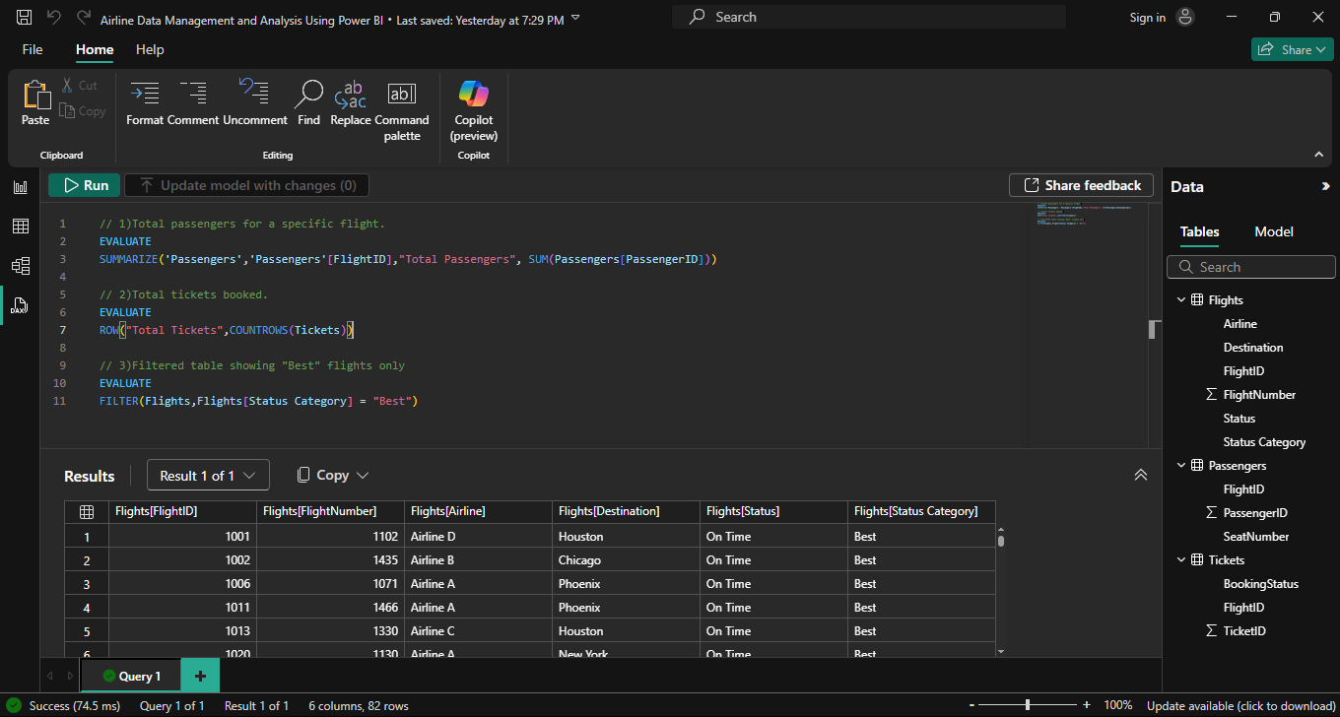

### ****Task 5 – Visualizations and Interactivity****

I built an interactive dashboard with:

* Passenger count by airline (Bar Chart).
* Ticket booking status (Donut Chart).
* Flights by airline and destination (Bar Chart).
* Table with flight details and KPIs.
* Slicers for Airline, Destination, StatusCategory, and BookingStatus.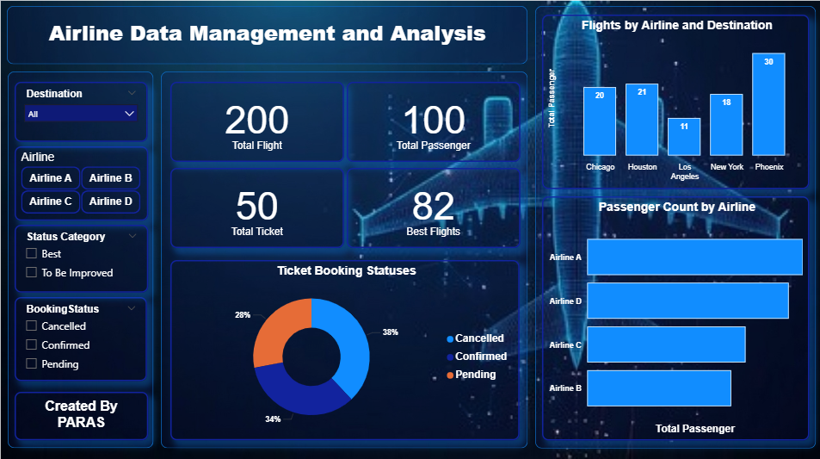

### ****Task 6 – Final Dashboard & Power BI Service****

* **Row-Level Security (RLS)**: Created a role for Airline A so only relevant data is visible.
* **Published** the report to Power BI Service.
* **Scheduled Refresh** set to run daily at **5:00 PM**.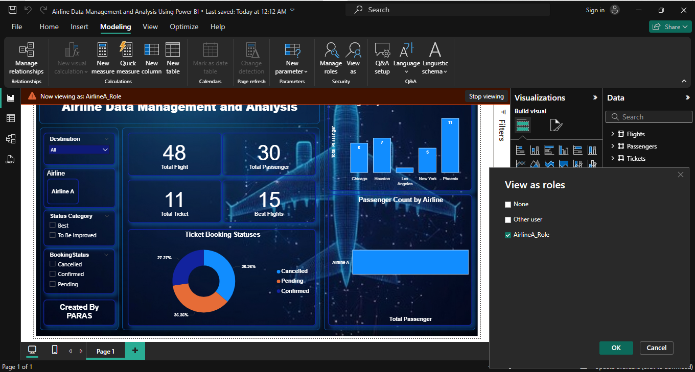

## ****4. Key Insights****

1. Airline A has the highest number of passengers.
2. Most flights are classified as “Best” based on their status.
3. Phoenix is the top destination in terms of passengers.
4. Confirmed tickets are the largest booking category.

## ****5. Conclusion****

This project shows how Power BI can connect multiple datasets, clean and transform data, and create interactive dashboards that make airline operations easier to monitor. With RLS and scheduled refresh, the dashboard stays updated and secure for different users.